Table of Content

Sr. No. Topic

List of Figures

List of Table

Abbreviation

Abstract

# 1. Introduction

## 1.1 Problem Specification

## 1.2 Solution Outline

## 1.3 Application/Usage

# 2. System Analysis

## 2.1 Existing System (If any)

## 2.2 Software Requirement

## 2.3 Hardware Requirement

# 3. Design and Methodology

## 3.1 Flowchart of App

## 3.2 Output (Screenshot of the app)

## 3.3 Limitation of App

# 4. Conclusion and Future Scope

# 5. References

**TASK REMINDER**

**A Mini-Project Report**

**Under**

**Implementation of Technology**

***Submitted by***

Yashashwini Gupta

GVA Sashank

Syed Ashraf Hussain

***in partial fulfillment for the award of the degree***

***of***

**B.TECH**

**IN**

**Computer Science**

**At**

**Mukesh Patel School  of Technology Management and Engineering Mumbai**

**April , 2015**

**CERTIFICATE**

This is to certify that the project entitled **Task reminder** is the bonafide work carried out by Yashashwini Gupta, GVA Sashank, Syed Ashraf Hussain B.Tech (Computer Engineering), MPSTME (NMIMS), Mumbai, during the fourth semester of the academic year 2014-2015, in fulfillment of the requirements for the award of the Degree of Bechelors of Technology as per the norms prescribed by NMIMS. The project work has been assessed and found to be satisfactory.

_______________________ ________________________

Examiner 1 Examiner 2

________________________

Dean

Dr. S.Y. Mhaiskar

**DECLARATION**

We, Yashashwini Gupta, GVA Sashank, Syed Ashraf Hussain B.Tech (Computer Engineering), semester- IV, understand that plagiarism is defined as anyone or combination of the following:

1. Un-credited verbatim copying of individual sentences, paragraphs or illustration (such as graphs, diagrams, etc.) from any source, published or unpublished, including the internet.

2. Un-credited improper paraphrasing of pages paragraphs (changing a few words phrases, or rearranging the original sentence order)

3. Credited verbatim copying of a major portion of a paper (or thesis chapter) without clear delineation of who did wrote what.

4. We have made sure that all the ideas, expressions, graphs, diagrams, etc., that are not a result of our work, are properly credited. Long phrases or sentences that had to be used verbatim from published literature have been clearly identified using quotation marks.

5. We affirm that no portion of my work can be considered as plagiarism and we take full responsibility if such a complaint occurs. We understand fully well that the guide of the seminar/ seminar report may not be in a position to check for the possibility of such incidences of plagiarism in this body of work.

Signature of the Students:

___________ ____________ ___________ ____________

Name: ___________ ____________ ___________ ____________

Roll No. ___________ ____________ ___________ ____________

Place: Mumbai

Date: April 2015

**List of figures**

**Fig 1**

Flowchart

**Fig 2** Display of database

**Fig 3** Setting date and time

**Fig 4:** Editing a task

**Fig 5:** Menu for adding a new task

**Fig 6:**Notification

**ii)Abbreviations**

SDK :System development kit

ADT :Android Development Tools

RAM : Random Access Memory

INTRODUCTION

Problem Specification

Life today has become very fast. There are so many things happening at a particular time that there is need to multitask. Often while multitasking, people get carried away and forget many important things in lives. To ensure that one does not forget any important that has a deadline or has to be done, one can set up reminder with alarms.

Solution

To avoid forgetting important things, deadlines, etc we can use this application to set reminders. This application sets reminders for the desired time and at the time set the alarm starts ringing and a notification is shown.

Application

Task reminder is simple and easy to use android app.

It provides the user to set up reminders with alarms for various things like:

1) Pills

2) Meeting

3) Homework

4) Workout

5) Birthday

And many more

SYSTEM ANALYSIS

Existing system

1) Tasks

2) Remind Me

3) To do reminder

4) GTasks

5) To do list

6) Reminder Assistant

And many more

Software Requirements

1. The minimum android version required on the device is 4.4(KitKat).
2. For development:

Any java platform

ADT plugin

SDKs

Hardware Requirements

A minimum 256 MB RAM.

A minimum processor.

Atleast 5 MB free space in the internal storage.

Does not require a wifi or internet connection.

# DESIGN AND METHODOLOGY

## Flowchart of App

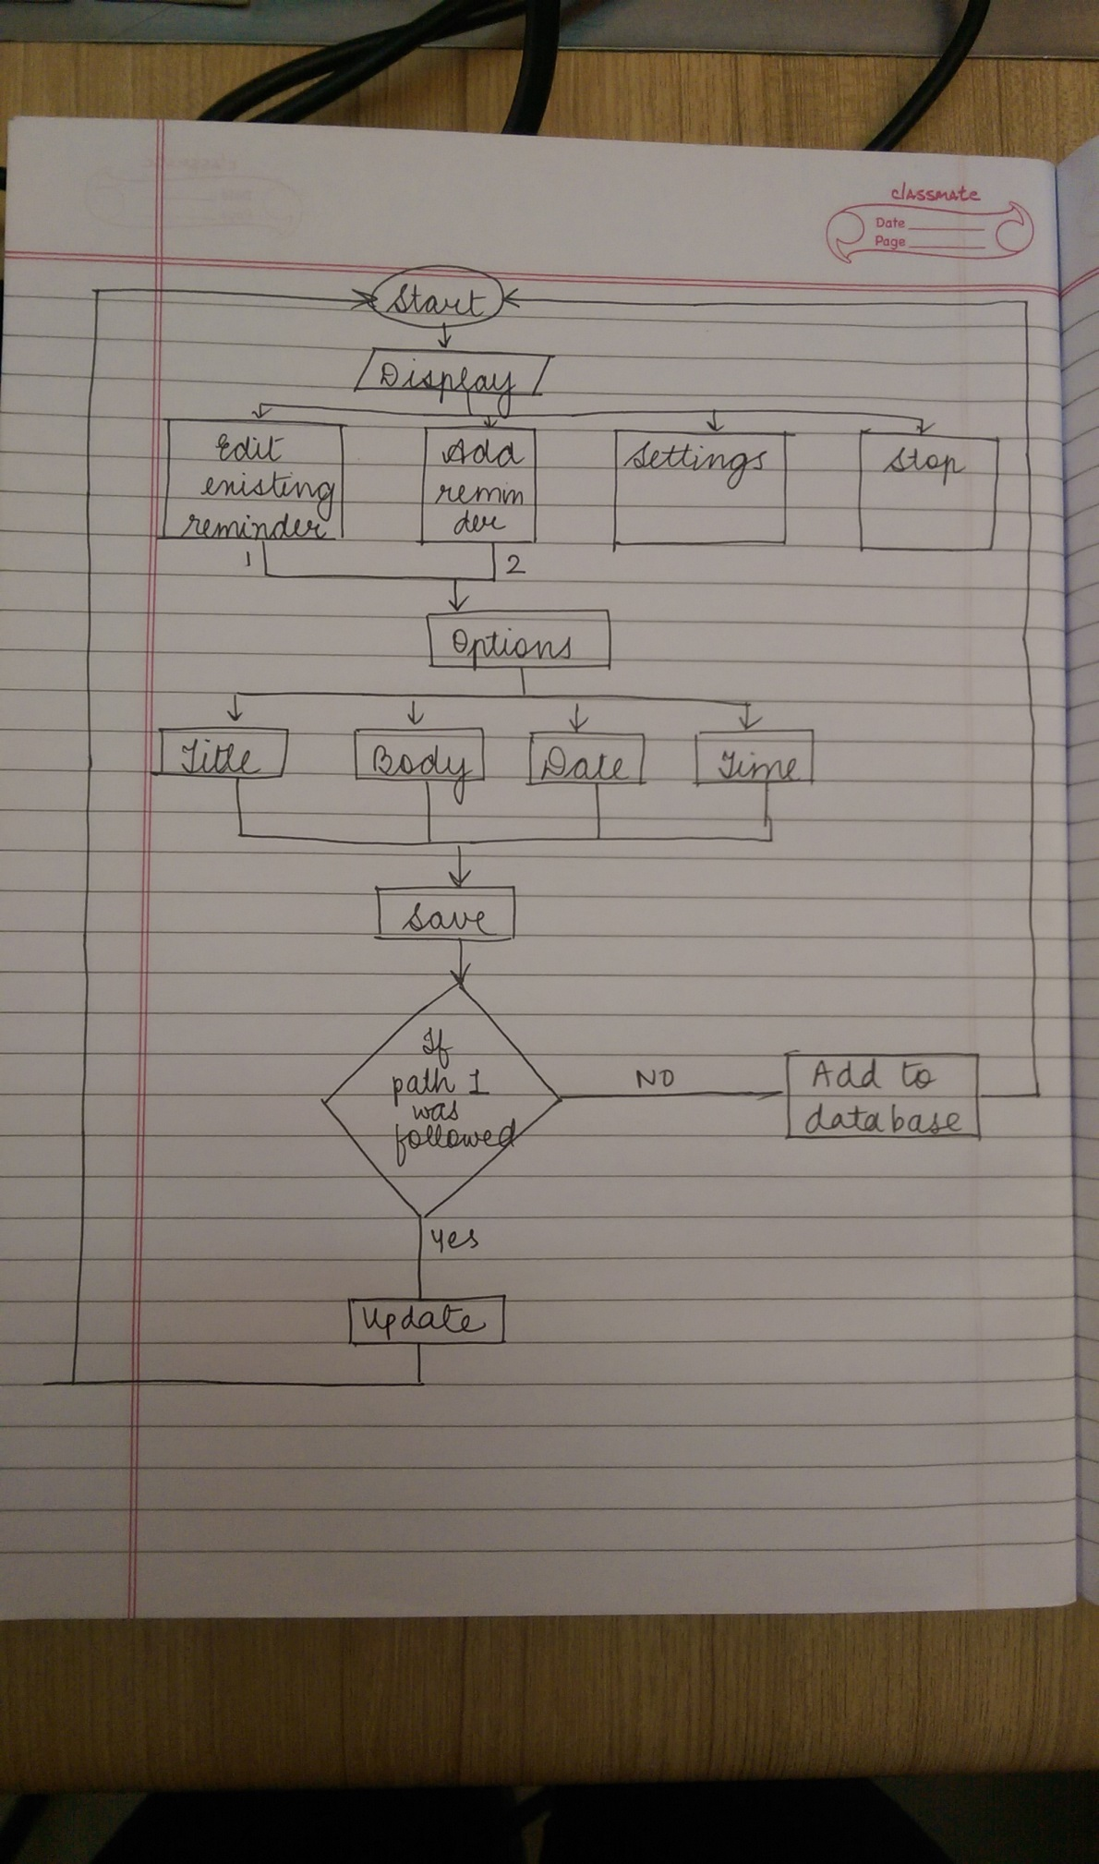

Figure 1:Flowchart of application

Uses of the Classes that we used in our application

**ReminderListActivity**

This class controls all the functions in the starting screen of the app.

User will have two options here –

1. Add Reminder - clicking on which would lead to list of various common tasks.
2. Settings – by clicking on this option user can set the default name and time for tasks.

Apart from these options, this class also controls the display of tasks. If there are no tasks it would display “No Reminders Yet”, else it would display the titles of the saved tasks.

The previously saved tasks can be deleted by long pressing on its name.

**TaskList**

When this class is called, a list of all the commonly used tasks like meetings, workouts, homeworks etc… gets displayed . User has to select the preferred task from the options , when its done the screen changes , to Edit Activity which is controlled by ReminderEditAtivity Class.

**ReminderEditActivity**

This class controls the various attributes of a task like title , date , time and description .

User needs to enter the required info in the respective fields . When its done and user enters “Save”, the entered info gets stored in a local database.

**RemindersDbAdapter**

This class creates a local database , which stores the title , description , time and date at which user needs to be reminded of the particular task. This class also supplies info to other classes when required to perform a specific function .

## 

## **Output (Screenshot of the app)**

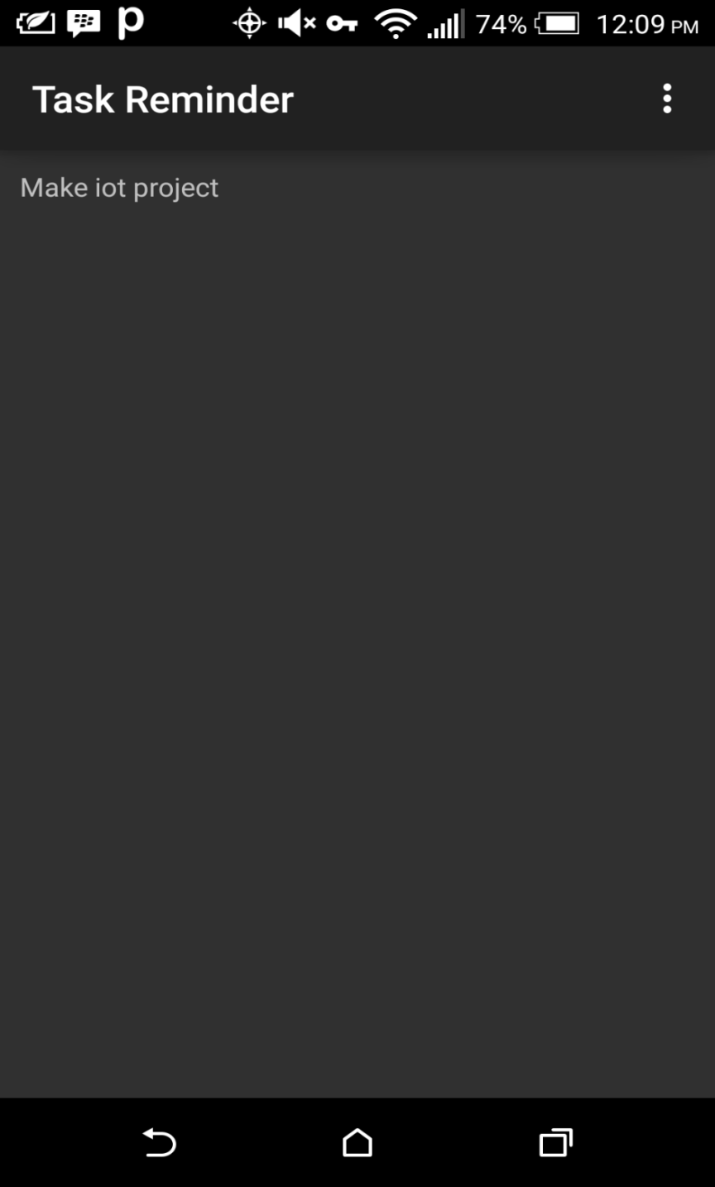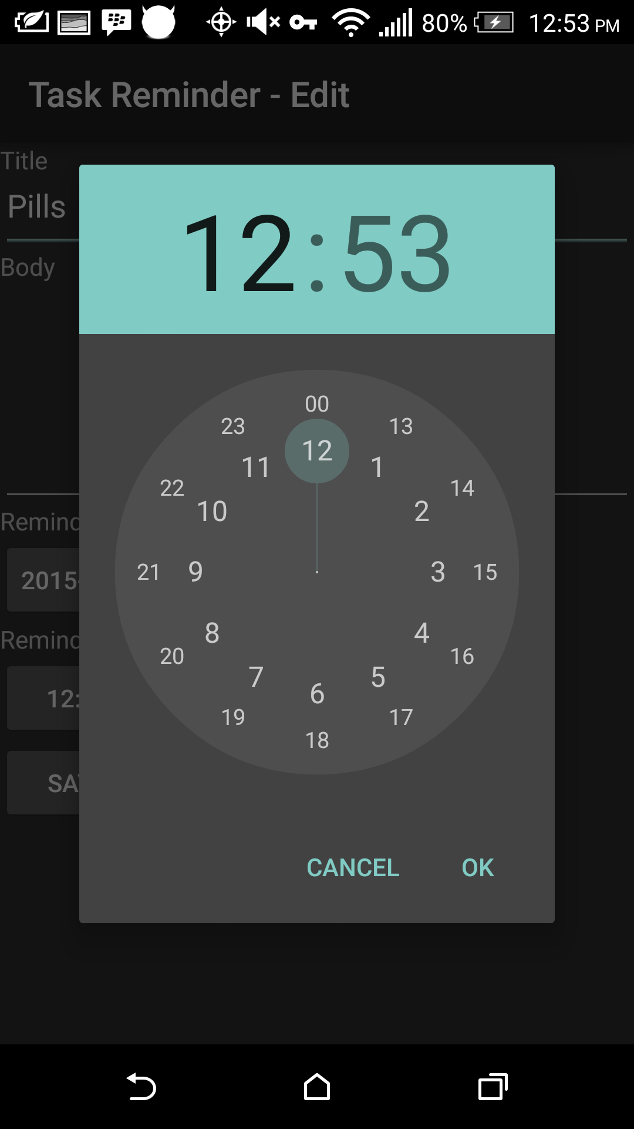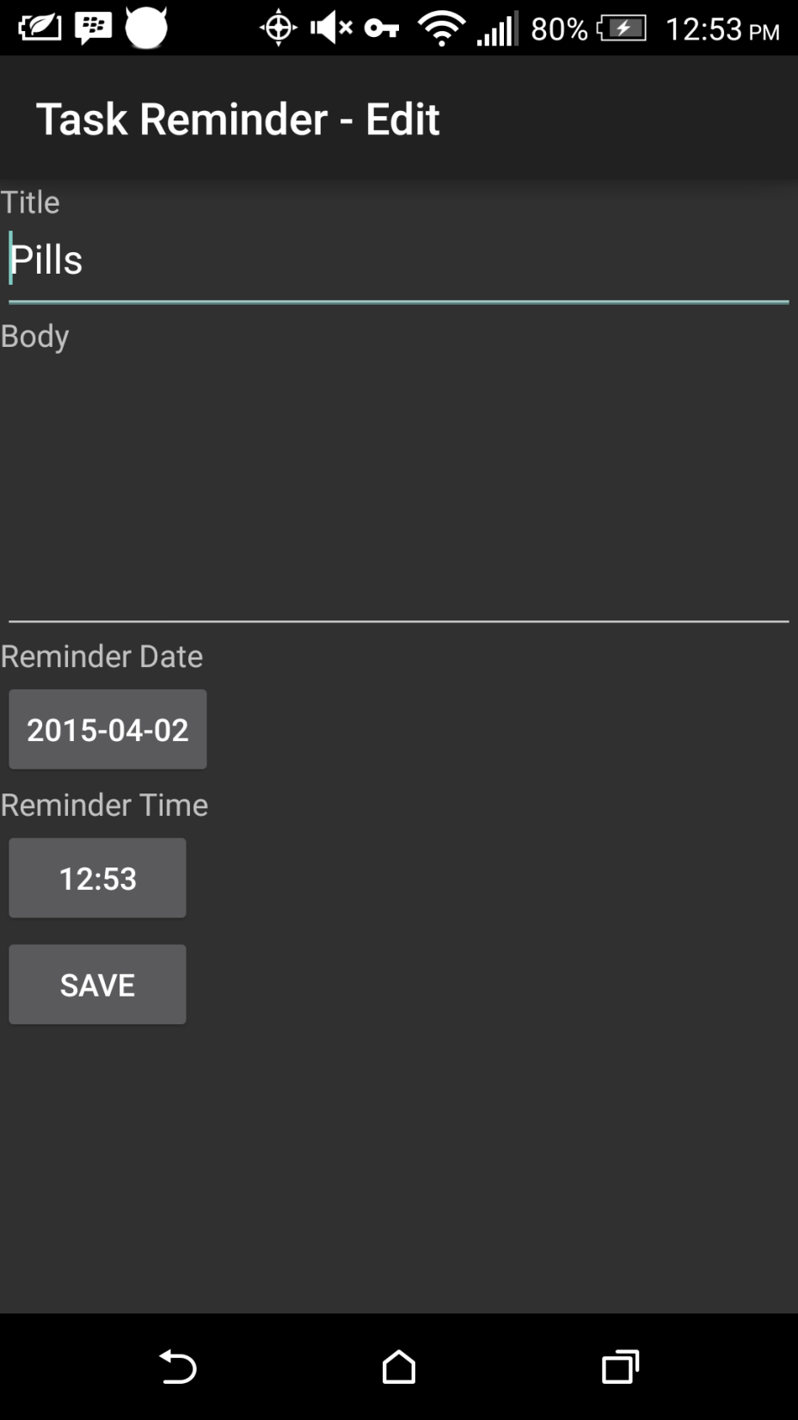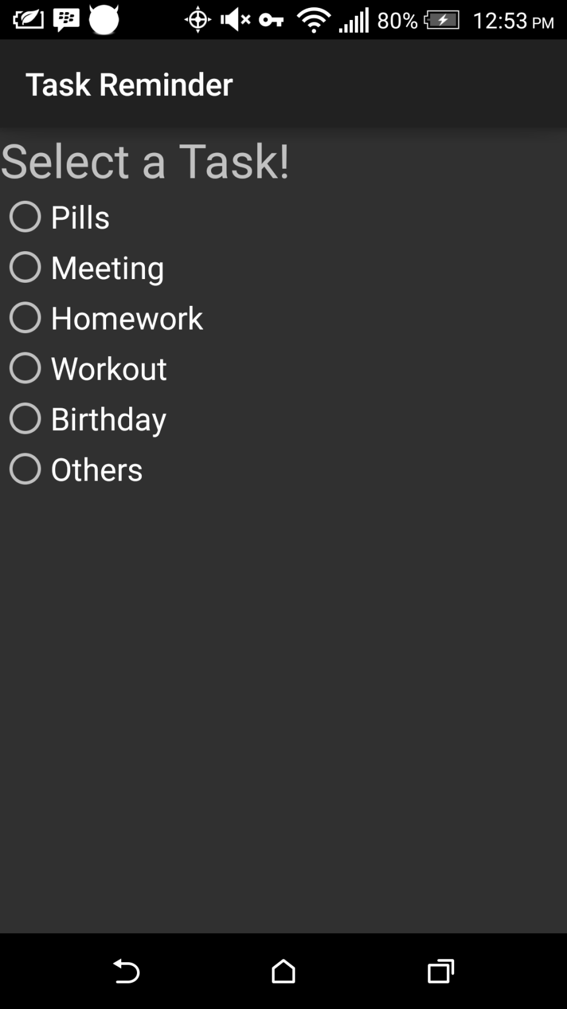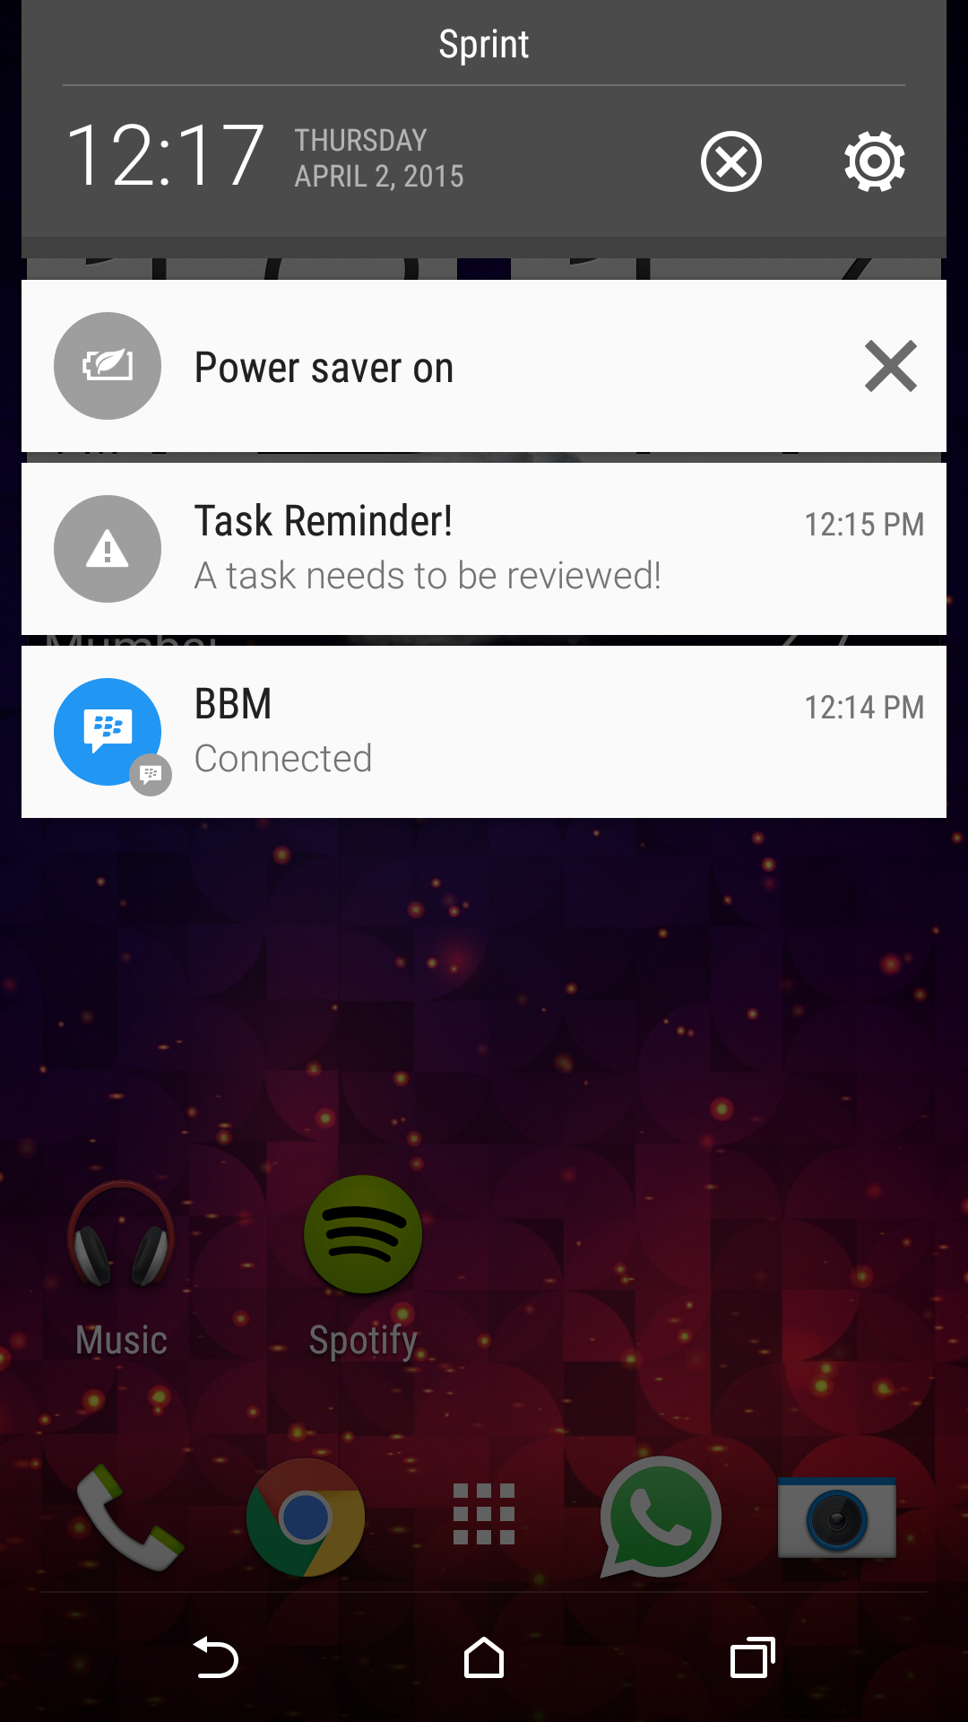

Figure 2:Display of database

Figure 3: Setting date and time

Figure 4:Editing a task

Figure 5: Menu for adding new reminders

## Figure 6:Notification

## Limitation of App

The application only allow user to set and edit reminders with alarms. The content of the reminder is not shown in the notifications. Repeating alarms cannot be set.

# CONCLUSION AND FUTURE SCOPE

# We learnt the basics of android application development . Learned the implementation of intents and creating a database . This app is a basic app which would user remember the daily tasks of life .

# REFERENCES

Google.com

Youtube.com

[Professional Android 2 Application Development Book](http://erclk.about.com/?zi=0/3W%5Bc)by Reto Meier

Stackoverflow.com